**PERSONAL TECHNICAL PORTFOLIO DOCUMENTATION**

**1. INTRODUCTION:**

**1.1 Overview:**

A portfolio is a collection of financial investments like stocks, bonds, commodities, cash, and cash equivalents, including closed-end funds and exchange traded funds (ETFs). People generally believe that stocks, bonds, and cash comprise the core of a portfolio.

**1.2 Purpose:**

A portfolio is a systematic collection of student work that represents student activities, accomplishments, and achievements over a specific period of time in one or more areas of the curriculum. There are two main types of portfolios: Showcase Portfolios: Students select and submit their best work

**2. LITERATURE SURVEY:**

**2.1 Existing Problems:**

**Among the most widespread business problems that may come in the way of successful project portfolio management are poor visibility, productivity gaps, collaboration and communication issues, and suboptimal project selection.**

**Most of those pain points can be eradicated by a PMO and supported by an industry-grade PPM software tool.**

2.2 **Proposed solution:**

Your documentation should, of course, relate to the Learning Outcomes and competencies of the courses you’re challenging.

When you start thinking of possibilities, keep this key factor in mind: your portfolio needs to display college-level learning. When choosing your documents, think about the level of thinking they demonstrate.

**3. THEORITICAL ANALYSIS:**

The modern portfolio theory (MPT)is a practical method for selecting investments in order to maximize their overall returns within an acceptable level of risk.

**3.1 Block Diagram** 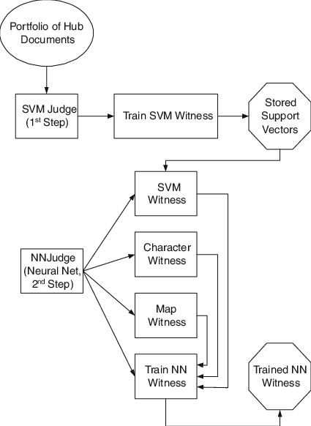

3.2  **Hardware/software designing:**

Architecture. All computer operating systems are designed for a particular computer architecture. ...

Processing power. The power of the central processing unit (CPU) is a fundamental system requirement for any software. ...

Memory. ...

Secondary storage. ...

Display adapter. ...

Peripherals.

**4.RESULT:**

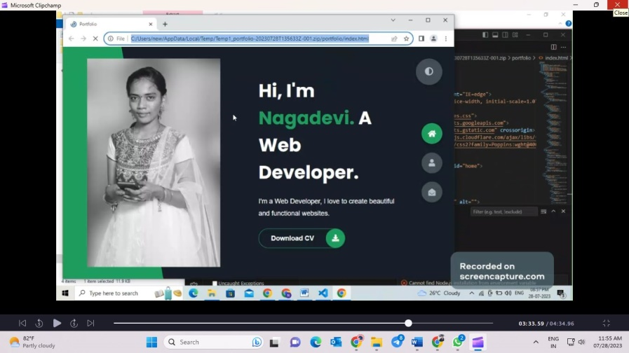

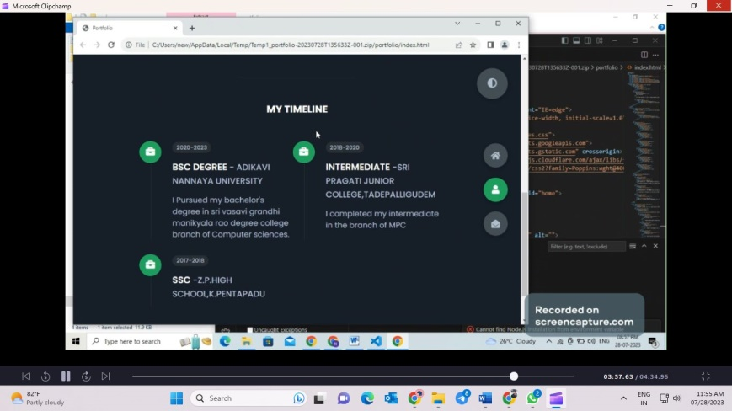

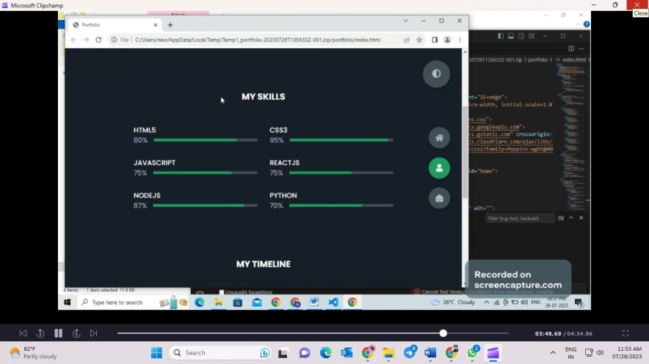

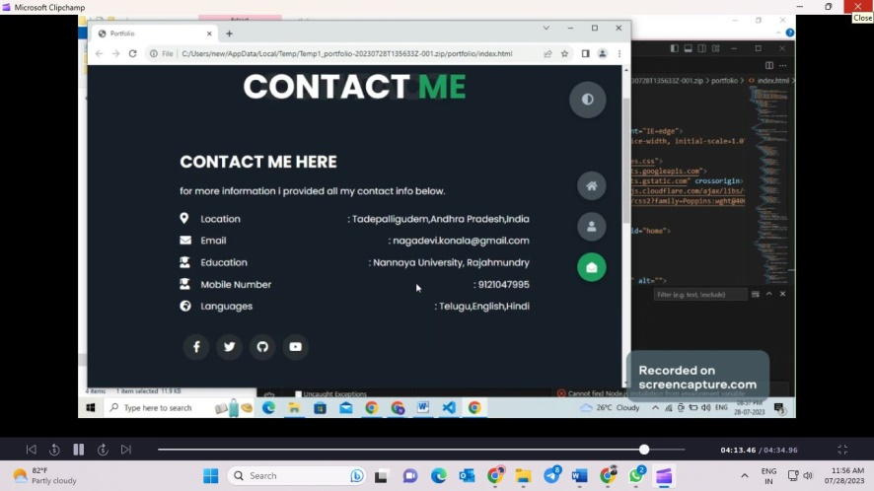

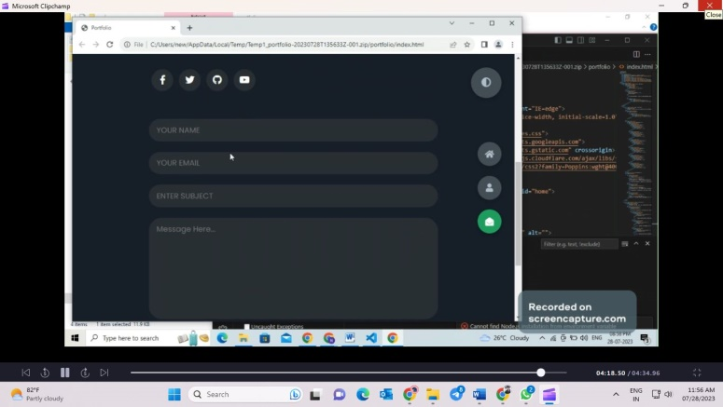

**5.ADVANTAGES &DISADVANTAGES:**

Gathering all of the necessary data and work sample can make portfolios bulky and difficult to manage.Portfolios are personal documents and ethical issues of privacy and confidentiality may arise when they are used for assessment.

**6.APPLICATIONS:**

Your technical portfolio is a key element in your search for a job as an engineer or developer. It’s an opportunity to showcase your skills through the projects you’ve worked on and shows prospective employers just what you’re capable of.

**7. CONCLUSION:**

Throughout this portfolio you can see that my work was a progress from the rough draft to the polished draft. All of the work I composed onto this file was the journey I went through this course**.**

**8. FUTURE SCOPE:**

While portfolios have seen an unprecedented surge in popularity, they have also become the subject of controversy: learners often perceive little gain from writing reflections as part of their portfolios; scholars question the ethics of such obligatory reflection; and students, residents, teachers and scholars alike condemn the bureaucracy surrounding portfolio implementation in competency-based education.